**Project Overview:**

This is an update to the previous request. The scope has been reduced for the initial release of the game, and a few additional items have been added. We are targeting an October release,and will need updates completed by August.

Below is a list of the revisions needed. The additions that were not part of the previous request have been highlighted in yellow.

If the estimates that were part of the previous request are still accurate, all we need are estimates for the new items.

Old Request for Reference:

[Red Hot: Wild Beyond Revisions](https://docs.google.com/document/d/18qOifG4vsEpVzhYWdfljGgw-ZrsO3ZqU0ajyE0GhmXg/edit)

Given scheduling and amount of work, it is understandable if you're not able to work on all of the items. Please only respond to the sections that you feel are the best fit.

Thank you for all the help!

New Art Request:

|  |  |
| --- | --- |
| **Supergame UI** | Quantity |
| 2D UI Homescreen | 1 |
| 2D Splash Screen | 1 |
| Various UI icons and buttons | 20 |
| 2D backgrounds on commander select, etc | 4 |
| 2D UI Banners | 3 |
|  |  |
| **Battle** |  |
| 2D concepts for environment prop updates | 20 |
| 3D environments props | 20 |
| 3D Battle Intro Sequence: 2D Concept Unit | 1 |
| 3D Battle Intro Sequence: 3D Model Unit | 1 |
| 3D Battle Intro Sequence: 3D Unit Rig | 1 |
| 3D Battle Intro Sequence: 3D UnitTexture variants | 3 |
| 3D Battle Environment updates: 2D concepts | 3 |
| 3D Battle Environment updates: 3D models | 3 |
|  |  |
| **Commanders Revisions** |  |
| 2D Concept Commander Heads | 6 |
| 3D UI Model Commander Heads | 6 |
| 3D In-Game LOD of Commander Heads | 6 |
| 2D concepts props (hats) | 5 |
| 3D props (hats) UI and In-game LOD | 5 |
|  |  |
| **Commander** |  |
| Commander 2D Concept | 1 |
| Commander UI and In-Game LODs 3D model | 1 |
| Commander 3D Rig | 1 |
|  |  |
| **Supergame 3D** |  |
| Upgrade chamber 2D concepts set of props | 1 |
| Upgrade chamber 3D environment set of props | 1 |
| Gacha cave 2D concepts set of props | 1 |
| Gacha cave 3D set of props | 1 |
|  |  |
| **Onboarding video Estimates** |  |
| 2D version | 1 |
| 3D version | 2 |

**Supergame 2D UI**

**2D UI Homescreen Final Render:**

New Homescreen UI: new art at design needed to replace existing home screen

Sky, Islands, and Buildings will need to be on separate layers

Retain UI layout

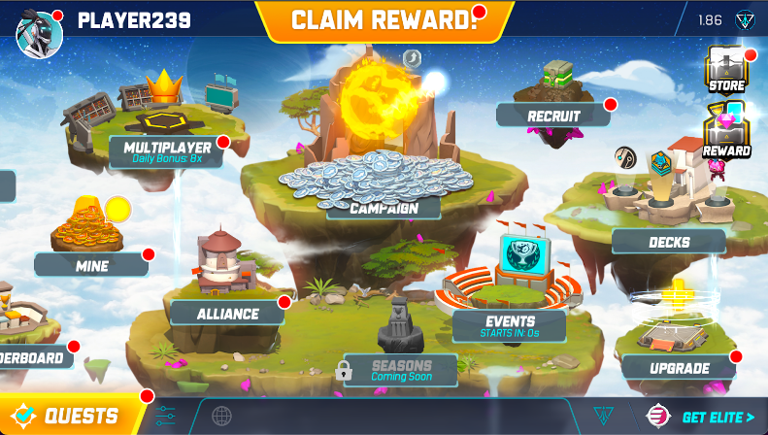

**2D Splash Screen:**

Splash screen art featuring new commanders in battle 4k, 4096x2160:

Example:

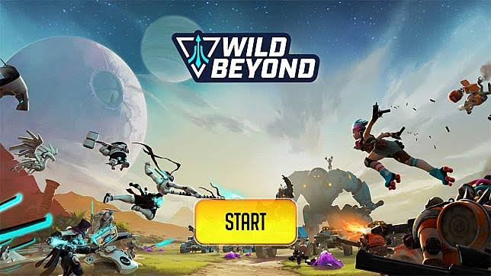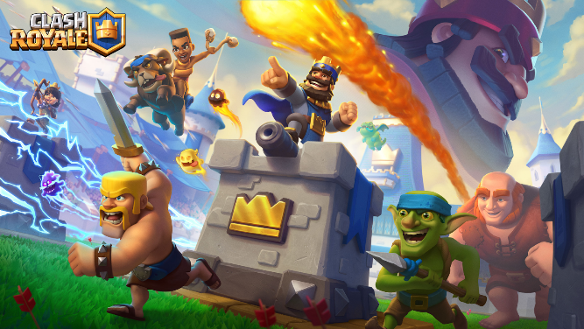

**2D Backgrounds for UI screens:**

We need 4 2D backgrounds images to be used behind characters in the UI.

2048x2048 resolution

References:

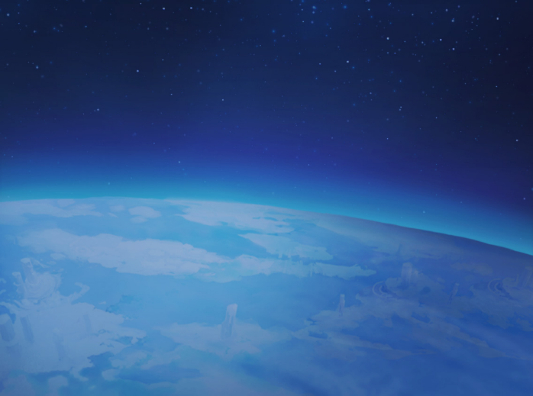 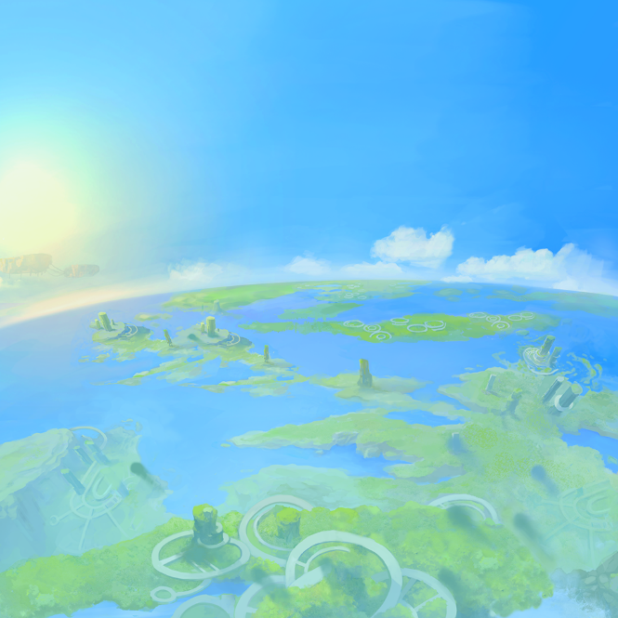

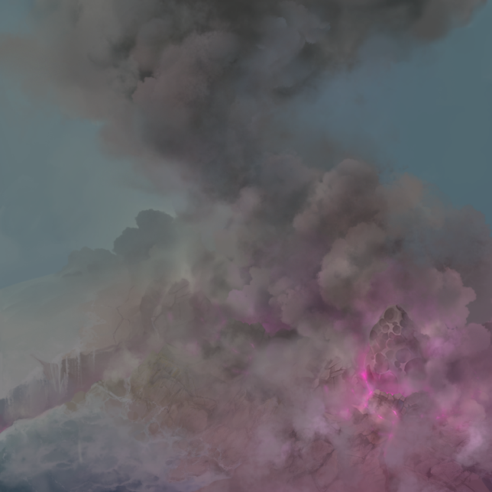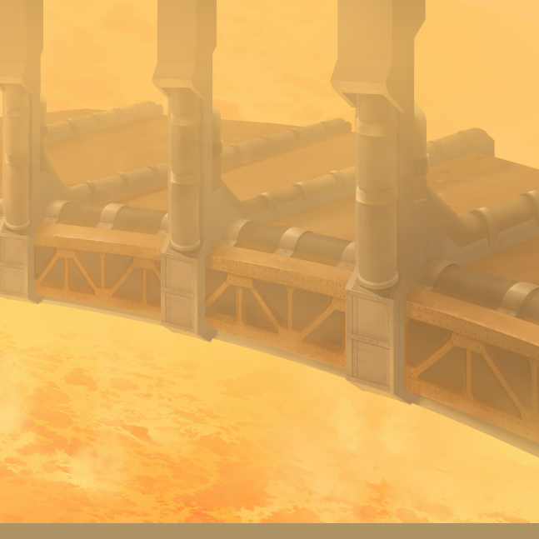

**Various UI icons and buttons:**

20x various UI Buttons

Ref:

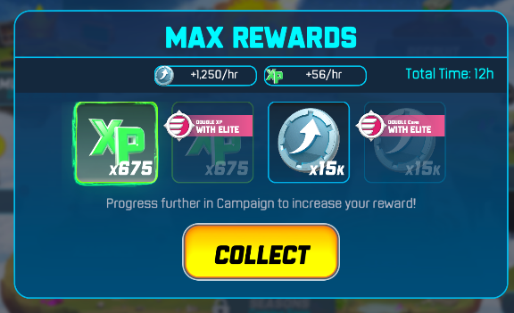

**2D UI Banner**

One banner with 3 Rank and Color variation. The goal is that the banner will become more impressive from each banner to the next.

Reference Banners:

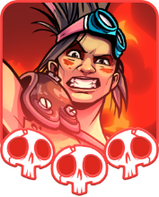 

**Supergame 3D Enviornment**

**ToxicUpgrade Chamber**

Upgrade chamber 2D concepts set of props

Upgrade chamber 3D environment set of props

Reference:

Image used low poly prototype assets, final art will be high poly with normal maps

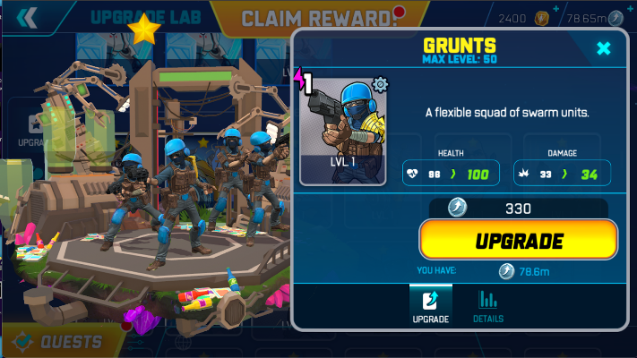

**Gacha Cave:**

10x 3D prop models at UI quality to decorate the cave

Gacha cave 2D concepts set of props

Gacha cave 3D set of props

Reference:   
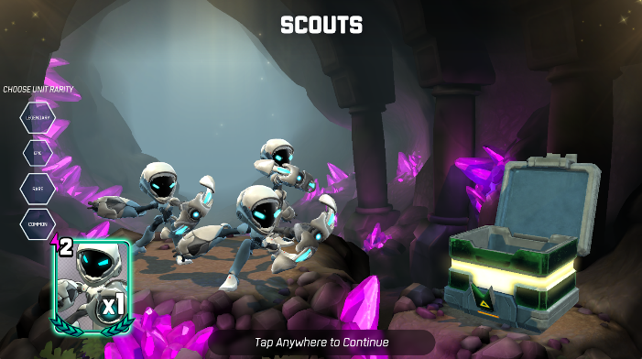

**In-Game Battle Environment**

**3D Environment props**

2D concepts phase for environment prop x20

3D environments props x20

In Game props need to match the style and approximate tri count of in-game Units. We are flexible on the tri count with the target being on the low side. Diffuse map only. Trees, building, rocks, garbage, broken equipment, are some examples of the props that will be used to decorate the environment

Examples:

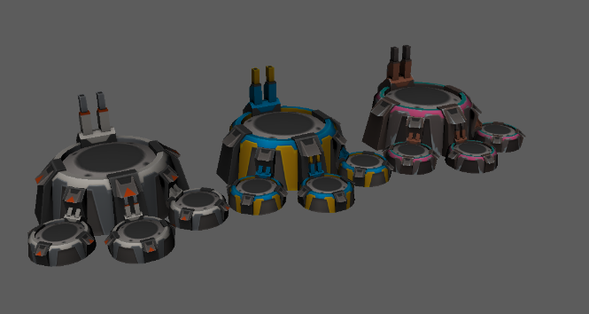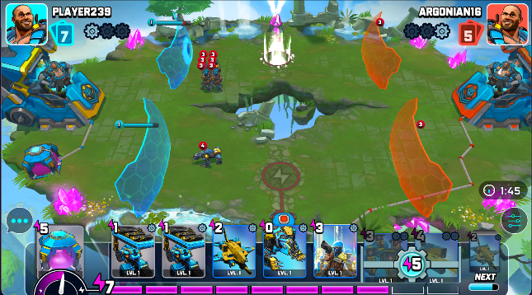

**3D Battle Environment updates:**

The current battle environment is a floating island. Additional terrain will need to be built around the island so it no longer looks floating, but is part of the surrounding terrain.

2D concepts drawing over the existing island

3D model the blends with the existing island’s mesh

Reference:

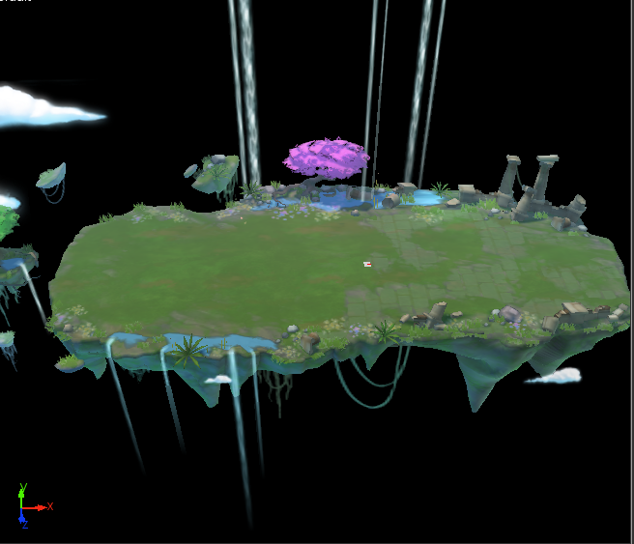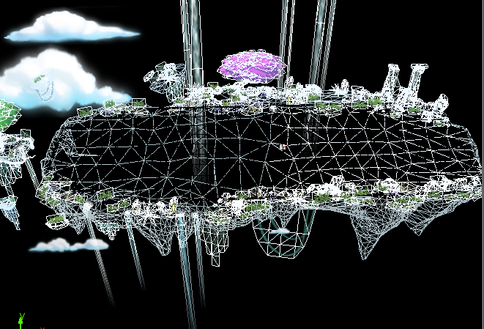

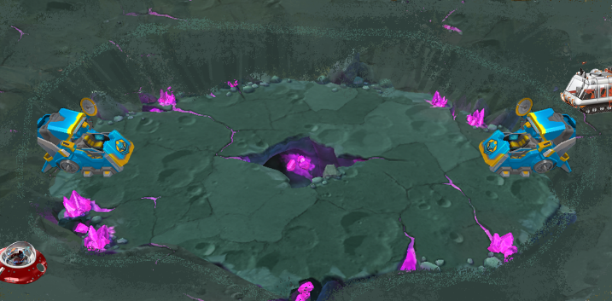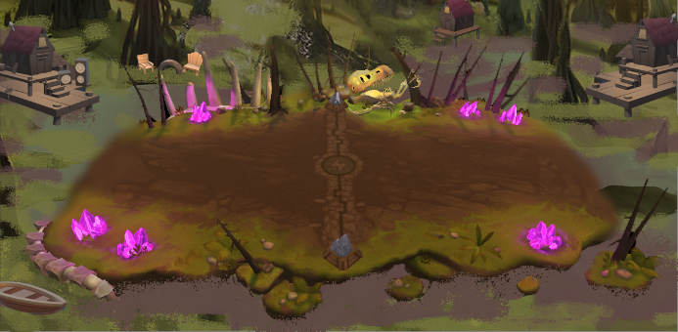

**In-Game Battle Unit**

**3D Character Unit**

1 new battle unit is needed,

2D Concept Character Unit:

3D Model Character Unit:

3D Rig Character Unit:

3x color variations of the characters textures

**Deliverables/Requirements:**

* 4k - 6k triangles range or less, rough estimate
* Author substance file at 2048x2048
* final .ZTL highpoly
* final Bake assets (fbx high and low files, maya files, etc)
* final Substance Painter scene
* final Maya file

**Software Used:**

* ZBrush (latest update is fine)
* Maya 2020+
* Substance Painter (latest update is fine)
* Photoshop CC

**Unit Rigs:**

* Full Character rig (no face) 24 bone count limit or less

**Examples:**

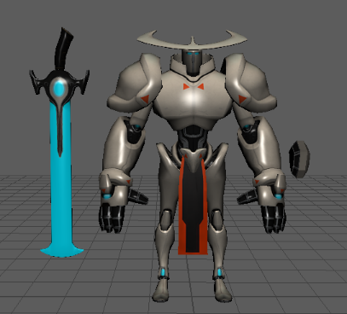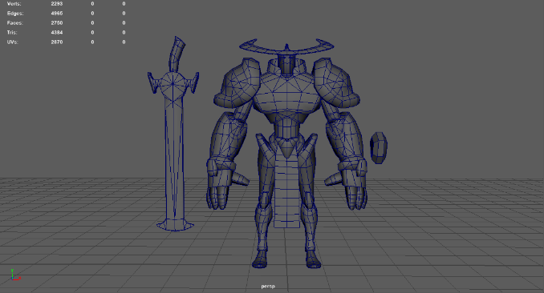

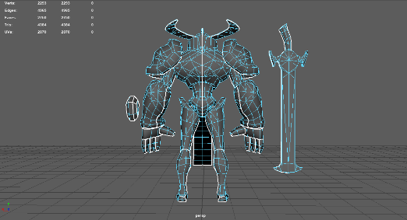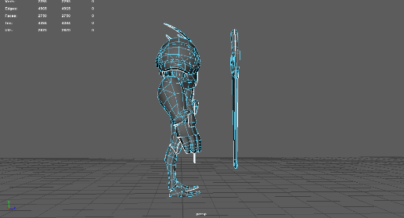

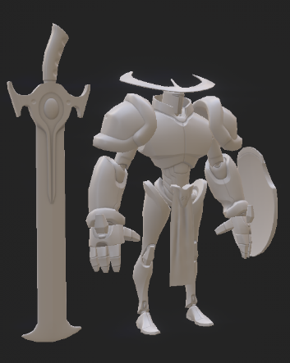 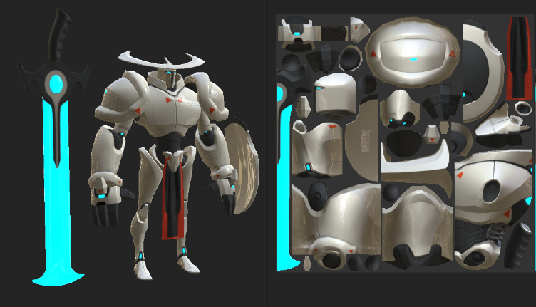

**Unit style**:

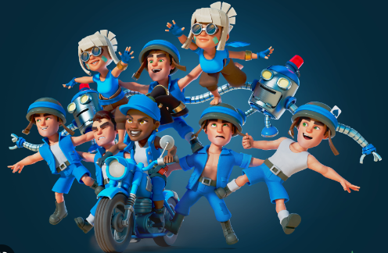

**Character Props**

5x 3d props needed with 2 LOD, a high poly with normal maps, and a low poly with diffuse only

2D Concepts pass needed on Hats

3D Models Hats

**New Commander and Old Commander Revisions**

**Commanders:**

1 New Commander and replacing the heads of 6 existing Commanders

Commanders need articulate eyes, lids that support blinking, and articulate mouths and interior mouths. All fingers are individual. Commanders also include weapons and props.

There will be two versions of the commander’s mesh needed. One in the 12k tri range, and one reduced to 4-6k tri for LOD.

In addition to the new commander, we would like an estimate replacing the heads of our 6 current commanders.

Commanders will need:

* Concept phase for commander and each revision.
* High Quality model and Rig for the UI
* Low Quality down-rezzed version of the model and rig for in-game

**High Poly Commander Example:**

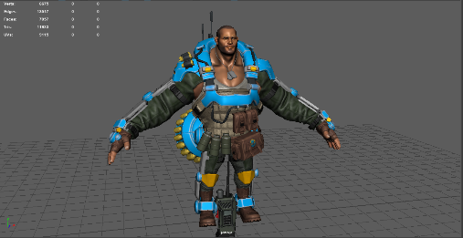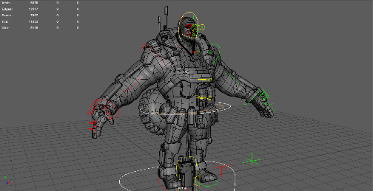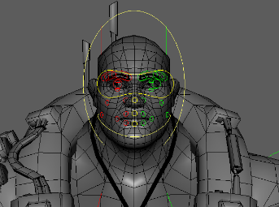

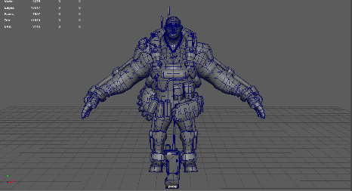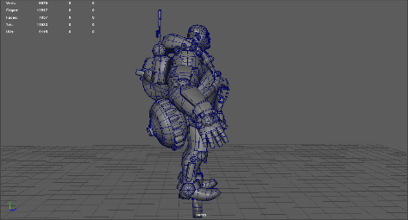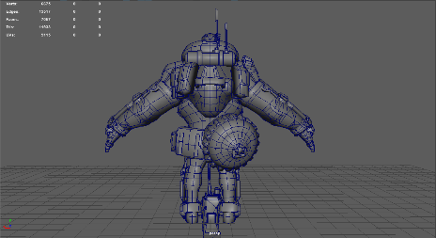

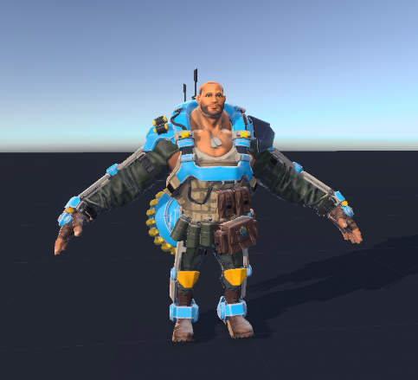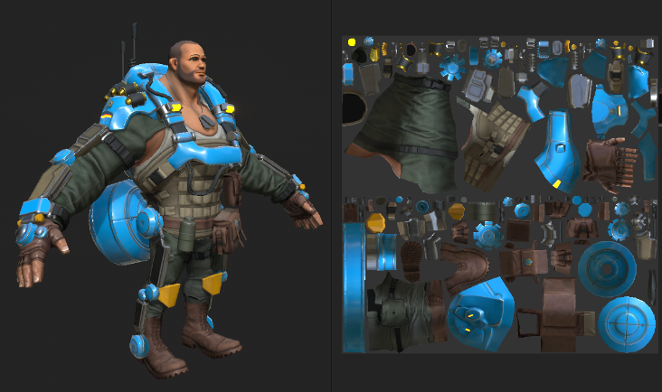

.

Commander Head Style:

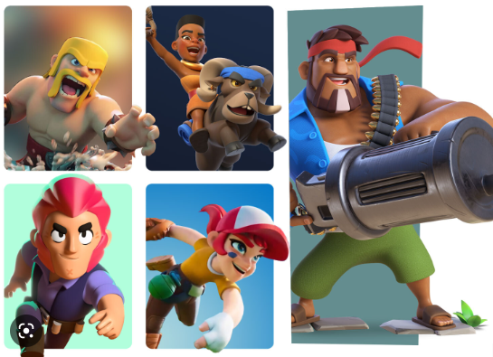

**Deliverables/Requirements:**

* High Poly 12k triangles or less, rough estimate
* Author substance file at 4096x4096
* final .ZTL highpoly
* final Bake assets (fbx high and low files, maya files, etc)
* final Substance Painter scene
* final Maya file

**Software Used:**

* ZBrush (latest update is fine)
* Maya 2020+
* Substance Painter (latest update is fine)
* Photoshop CC

**Commander Rigs:**

LOD High

Full Body rig 30-40 Joint count range

Full Face rig 20-30 Joint count range

LOD Low

Full Character rig (no face) 20 bone count limit or less

**Onboarding Video**

**2D Version**

We need an estimate on 20 to 30 second 2D trailer with13 animated frames, 4 of which will be adjusted and reused. Illustrations will be created and animated in Photoshop and After Effects, or similar. The total frames will be 17. We will provide storyboards. SFX and Music will also be needed.

**2D animation Reference:**

<https://drive.google.com/file/d/1titXvFMVv_e57KigWyFJbPdSu05TgBOA/view?usp=share_link>

**3D Version**

We need an estimated 1 minute to 1:30 second 3D animated trailer, similar in scope and style to the link below.

[**https://drive.google.com/file/d/1uBqA-s-FCXQ5bjfjWmxxC1-DUApe3234/view?usp=share_link**](https://drive.google.com/file/d/1uBqA-s-FCXQ5bjfjWmxxC1-DUApe3234/view?usp=share_link)

At 3 moments in the video it will cut to different 2D animated clips made in After Effects that play for approximately 5 seconds. We will provide the images to be animated. The 2D animations need to be seamless with the 3D environment.There will be only 2 animated characters in the game, the red haired lead, and the medic drone. All other cuts to characters will be replaced by cuts to 2D animated sequences.

2D/3D blend reference:

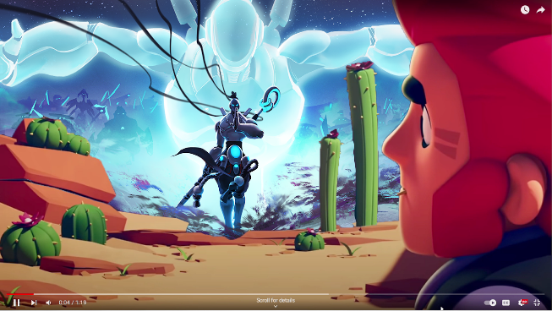

A version of the medic drone and legion grenade needs to be modeled, rigged and animated at a trailer quality. The medic drone preplaces the Purpled haired Character and Skeleton in the trailer, and the Legion Grenade replaces the Cactus grenade.

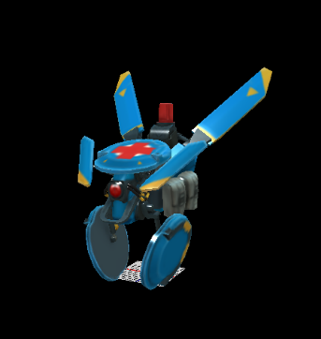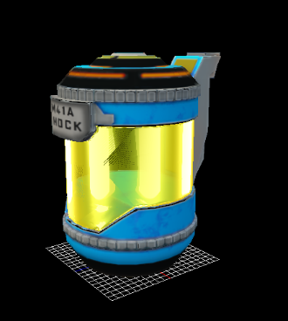

We needs 2 estimates for the video

**Estimate #1** We provide the 3D assets and animations, except for the medic drone and legion grenade. We will also provide the 2D animated images. The medic drone will need to be animated to match the video. The legion grenade will be needed to replace the cactus grenade. All 3D will need to be rendered, and the 2D images need to be edited into the video. SFX and music audio pass is needed as well as any vfx.

**Estimate #2** We provide storyboards only, and all other aspects will need to be developed.